Functional Specification – Smartform

1. Project:
2. FS Name: Quotation
3. Reference: NA | 4. Business Process: Sales and Distribution
5. SAP Module: SD | 6. Business Sub Process: Quotation - Forms
7. Author: | 8. Reviewed By:
9. Status: <Created/  Reviewed/Approved> | 10. Status Date:
11. Priority: <High/ Medium /Low> | 13. Process Owner : Upender Reddy N
12. Version No: 1.0

13. Document Revision History:
Rev. No. | Change Request No. | Affected Pages | Description of Change | Date of Revision

14. Definition:
Migration Title: | Output for the Quotation
Associated Business Event:
Application: | Sales and Distribution
Comments: | Quotation details should be displayed in the Form output

15. Purpose:

To design new smartform for Quotation Output for Sales and Distribution

16. Assumptions:

NA

17. Periodicity:

As and when required

18. Process Flow Diagram:

T.codes: VA22, VA23

19. Processing Logic:
- Create a print program and smartform from scratch, use ‘SSF_FUNCTION_MODULE_NAME’ to call the smartform in print program.

- Only Quotation entered on selection screen needs to be considered in this smartform:

- The Input and output screen of the Smartform is as per the attached worksheet:

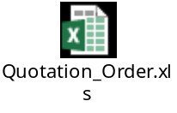

4. Refer the below word document for the logic that needs to be done in order to fetch all the
Details in the smartform

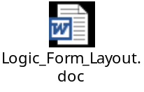

Approach:

- Retrieve the data from VBAK and VBAP on the base of Quotation entered on selection screen

- Based on Quotation get data from VBKD to get PO details

- Get Transaction details from KONV on the base of KNUMV document condition

- Finally create a Smartform with the attached output and display all the details

- Assign a Transaction code for this as ZSALES_QUOT

20. Selection Screen:
 | See the above attachment | Input Screen

21. Sign-Off

Signed-Off By:

Sign-Off Date:

